UNIVERSITY OF TRANSPORT AND COMMUNICATIONS

​FINAL REPORT
RESEARCH TOPIC STUDENT SCIENTIFIC RESEARCH
ACADEMIC YEAR 2025-2026

RESEARCH ON APPLYING YOLOV11 MODEL FOR OBJECT DETECTION ON FISHEYE CAMERAS

Performing students:
Full name | Class | Faculty
Nguyen Quoc Nam | CNTT1 - K63 | Faculty of Information Technology

Supervisor: PhD Nguyen Duc Du

TABLE OF CONTENTS
LIST OF FIGURES 3
LIST OF TABLES 3
LIST OF ABBREVIATIONS 4

PART 1: RESEARCH OVERVIEW 5
1.1. Introduction 5
1.2. Overview of Research Status 5
1.3. Rationale for Topic Selection 5
1.4. Objectives, Content and Research Methods 5
1.5. Research Subject and Scope 6

PART 2: THEORETICAL BACKGROUND 6
2.1. Fisheye Camera Geometry and Image Distortion 6
2.2. YOLOv11 Model Architecture 7
2.3. Loss Functions 9
2.4. Data Augmentation Techniques 9

PART 3: EXPERIMENTAL RESULTS 10
3.1. Proposed Model and Processing Pipeline 10
3.2. Data Collection and Preprocessing 10
3.3. Training Configuration 11
3.4. Performance Evaluation Metrics 12
3.5. Training Results and Analysis 12
3.6. Comparison with Previous YOLO Versions 13

PART 4: WEB APPLICATION FOR TRAFFIC MONITORING SUPPORT 13
4.1. Application Overview 13
4.2. Main System Functions 14
4.3. System Architecture 14
4.4. Data Processing Flow 14

PART 5: FUTURE TRENDS AND STRATEGIC RECOMMENDATIONS 15
5.1. Super-Resolution for Small Object Detection 15
5.2. Advanced Multi-Object Tracking 15
5.3. Edge Optimization and Deployment 16

CONCLUSION AND RECOMMENDATIONS 16
REFERENCES 17

LIST OF FIGURES
Figure 2.1. Illustration of barrel distortion in fisheye lens 7
Figure 2.2. Overall architecture diagram of YOLOv11 (Backbone, Neck, Head) 7
Figure 2.3. Detail of C3k2 block and AIFI Transformer mechanism 8

LIST OF TABLES
Table 3.1. Label statistics in the FishEye8K dataset 11
Table 3.2. Model training hyperparameters 12
Table 3.3. Detailed performance of YOLOv11-L per object class 13
Table 3.4. Performance comparison between proposed model and baselines 13

LIST OF ABBREVIATIONS
Abbreviation | English | Vietnamese Meaning
AIFI | Attention-based Intra-scale Feature Interaction | Attention-based intra-scale feature interaction
C3k2 | Cross Stage Partial with kernel size 2 | CSP block with kernel size 2
CIoU | Complete Intersection over Union | Complete IoU metric
CNN | Convolutional Neural Network | Convolutional neural network
DFL | Distribution Focal Loss | Distribution-based focal loss function
FPS | Frames Per Second | Number of frames per second
GPU | Graphics Processing Unit | Graphics processing unit
mAP | mean Average Precision | Mean average precision across classes
SPPF | Spatial Pyramid Pooling – Fast | Spatial pyramid pooling – Fast
YOLO | You Only Look Once | Single-stage object detection model

PART 1: RESEARCH OVERVIEW

1.1. Introduction
In smart urban management, fisheye cameras play a pivotal role by providing an ultra-wide field of view of up to 180° or 360°, helping minimize the number of devices installed at traffic intersections. However, fisheye images suffer from severe nonlinear distortion (barrel distortion), posing significant challenges for conventional AI models. This research investigates the application of YOLOv11 — the latest deep learning architecture of 2024 — to address the problem of direct traffic object detection on fisheye images.

1.2. Overview of Research Status
Current research focuses on two directions: rectifying images to a flat perspective, or learning directly from distorted images. YOLOv11 introduces significant improvements with the AIFI Transformer mechanism and C3k2 block, enabling the modelling of long-range dependencies — highly effective for recognising objects stretched at the edges of fisheye images.

1.3. Rationale for Topic Selection
The demand for 360° traffic monitoring in Vietnam is growing rapidly. Adopting YOLOv11 not only ensures superior mAP accuracy but also optimises parameters (22% reduction compared to YOLOv8), making it suitable for deployment on resource-constrained edge devices.

1.4. Objectives, Content and Research Methods
Objective: Build a YOLOv11-L model to detect 5 object classes (Car, Bus, Bike, Truck, Pedestrian) with mAP@0.5 above 0.4.
Content: Preprocessing FishEye8K and VisDrone data; model training; and web application development.
Method: Combining experiments on Tesla P100 GPU with modern data augmentation algorithms.

1.5. Research Subject and Scope
The research subject is the YOLOv11 model applied to traffic object detection in fisheye camera images. The research scope includes the FishEye8K and VisDrone2019 datasets, along with the development of a web application supporting real-time traffic monitoring.

PART 2: THEORETICAL BACKGROUND

2.1. Fisheye Camera Geometry and Image Distortion
Fisheye lenses use nonlinear projection to compress a hemispherical space onto a flat sensor. They deviate from the standard rectilinear pinhole model, which follows the relation:
r = f · tan(θ)
where r is the radial distance from the image centre, f is the focal length, and θ is the angle of the incident ray. Instead, fisheye lenses employ mappings such as equidistant (r = f·θ) or equisolid (r = 2f·sin(θ/2)) to map a wide hemispherical scene onto a flat sensor.
This mapping results in barrel distortion, where the magnification factor decreases with distance from the optical axis. For computer vision models, this presents three primary geometric difficulties:
- Prediction rigidity: standard grid-based detectors struggle because objects do not maintain a constant shape as they translate across the frame.
- Non-uniform resolution: objects near the boundary are compressed into fewer pixels than centrally located objects, causing loss of fine-grained detail.
- Curved edges: straight edges of vehicles appear as curves, confusing convolutional filters trained on standard perspective datasets.
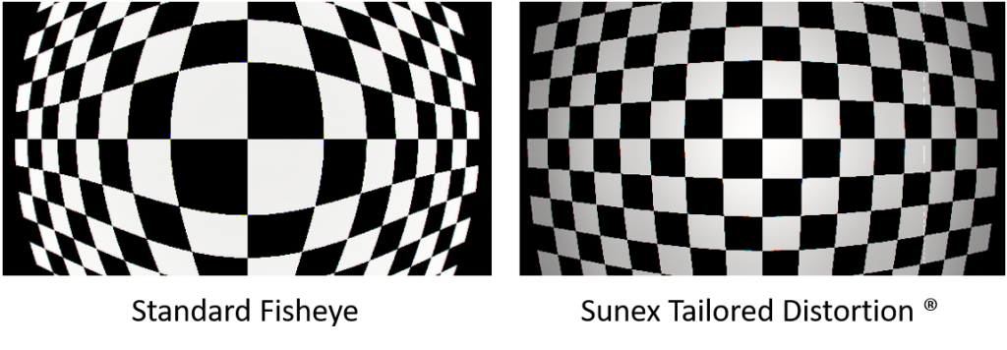
Figure 2.1. Illustration of barrel distortion in fisheye lens

2.2. YOLOv11 Model Architecture
YOLOv11 consists of three main components — Backbone, Neck, and Head — each playing an important role in the feature extraction and processing pipeline.
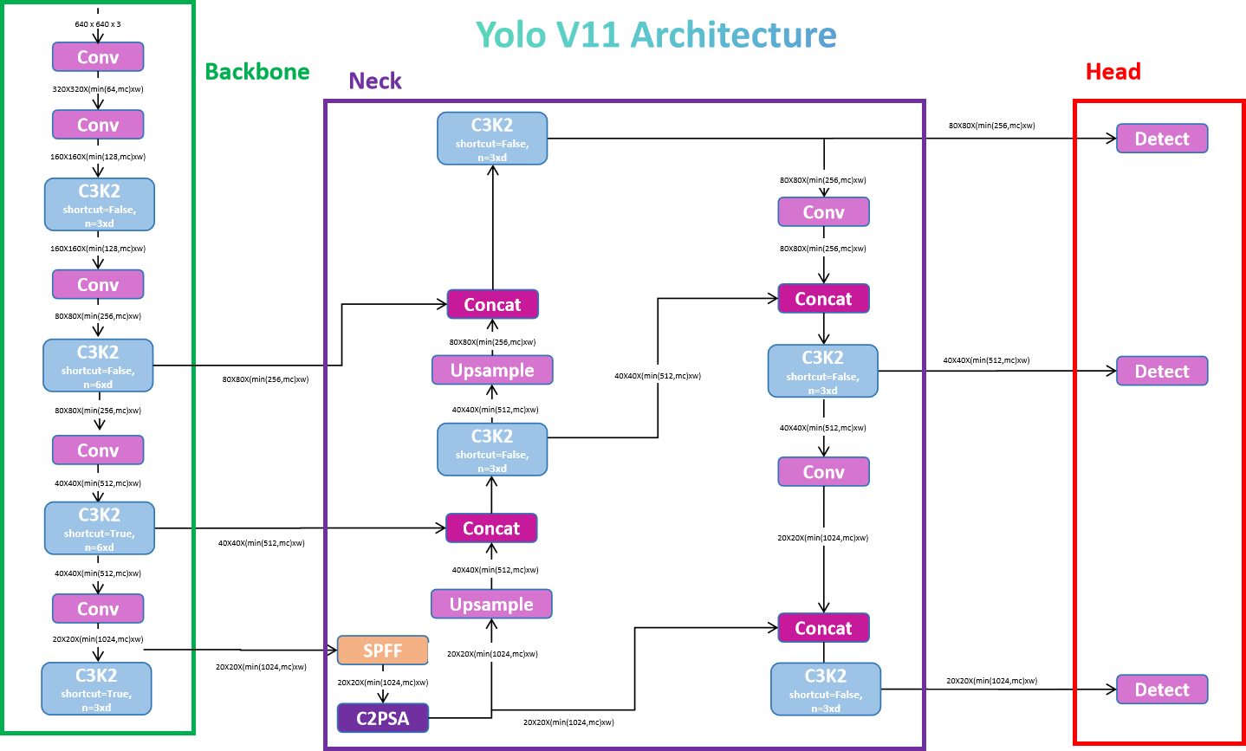
Figure 2.2. Overall architecture diagram of YOLOv11 (Backbone, Neck, Head)

2.2.1. Backbone and C3k2 Block
The backbone of YOLOv11 serves as the primary feature extractor, gradually reducing spatial dimensions while increasing channel depth. The core innovation is the C3k2 (Cross Stage Partial with kernel size 2) block, which replaces the C2f block found in YOLOv8 and YOLOv10.
The C3k2 block is a computationally optimised CSP module. It splits the input feature map into two paths — one unchanged, the other processed through bottleneck layers. Unlike previous versions using 3×3 convolutions, C3k2 employs two smaller 2×2 convolutions per path, reducing per-block FLOPs by 30–40%. This reduction minimises memory traffic while maintaining the network's ability to extract complex features — particularly valuable for the highly irregular feature space of fisheye imagery.
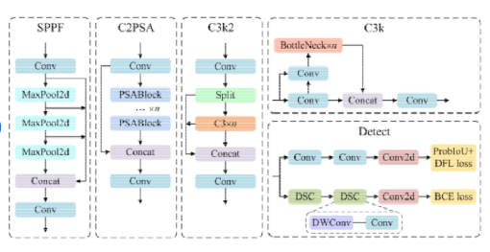
Figure 2.3. Detail of C3k2 block and AIFI Transformer mechanism

2.2.2. Neck and AIFI Mechanism
The Neck performs bidirectional feature aggregation across three distinct scales: P3 (stride 8), P4 (stride 16), and P5 (stride 32). The key improvement is the AIFI (Attention-based Intra-scale Feature Interaction) mechanism — a Transformer-based self-attention layer applied to the deepest feature maps.
In standard CNNs the receptive field is limited to local neighbourhoods, but in fisheye images the context of an object near the edge may be influenced by patterns across the entire image. The AIFI mechanism captures these long-distance pixel dependencies, enabling the model to better understand the relationship between distorted image regions. Additionally, the C2PSA (Cross-Stage Partial with Spatial Attention) block injects a lightweight spatial attention mechanism over a CSP split, strengthening the model's focus on salient regions — critical for detecting small or partially occluded vehicles in congested urban traffic.

2.2.3. Detection Head and Anchor-free Approach
The detection head follows an anchor-free, multi-scale paradigm, with three parallel heads that predict objectness scores, per-class probabilities, and 4D bounding box regression offsets represented as the tuple (Δx, Δy, Δw, Δh) per cell.
The removal of predefined anchor boxes is particularly advantageous for fisheye applications. In traditional detectors, anchors were designed with fixed aspect ratios for perspective images, but vehicles in fisheye views can appear with extreme aspect ratios. The anchor-free design simplifies hyperparameter tuning and improves detection of small, densely packed objects — evidenced by a +2.5% increase in mAP@0.5 over YOLOv10. The head is also decoupled, with separate branches for classification and regression to improve convergence speed and localisation precision.

2.3. Loss Functions
YOLOv11 is optimised using three complementary loss functions:
CIoU (Complete Intersection over Union): governs localisation by accounting for overlap area, centre-point distance, and aspect-ratio consistency between predicted and ground-truth boxes.
DFL (Distribution Focal Loss): addresses ambiguity of object boundaries in blurry or heavily distorted fisheye regions by learning the probability distribution of box boundaries rather than performing single-coordinate regression.
BCE (Binary Cross Entropy): handles classification, ensuring accurate distinction between target classes. These functions work in tandem to balance the precision–recall trade-off, particularly for small objects such as pedestrians.

2.4. Data Augmentation Techniques
The training pipeline incorporates advanced augmentation to improve generalisation and prevent overfitting:
Mosaic v2: combines four training images into a single composite, forcing the model to detect objects in diverse contexts and scales — highly effective for small object detection in wide-angle surveillance.
Copy-Paste: copies objects within or between images based on a specified probability, artificially increasing the occurrence of rare classes (Truck, Bus) without requiring additional raw data.
HSV tweaks: adjusts Hue, Saturation, and Value channels to handle the extreme lighting variability found at outdoor intersections.

PART 3: EXPERIMENTAL RESULTS

3.1. Proposed Model and Processing Pipeline
The processing pipeline starts from a fisheye input image, passes through the C3k2 Backbone for feature extraction, then through the AIFI Neck for multi-scale information aggregation, and concludes at the Detection Head to produce bounding box coordinates and class probabilities for each detected object.

3.2. Data Collection and Preprocessing
The FishEye8K dataset (8,000 images) serves as the base. To address the shortage of Truck and Bus class samples, 6,000 images from VisDrone2019 were supplemented and converted using a custom Panorama-to-Fisheye pipeline. The total training dataset reaches 14,000 images after preprocessing.
VisDrone Conversion Pipeline. Implemented in Python using OpenCV and NumPy on Kaggle Notebook with GPU acceleration. Two custom functions were developed:
(1) to_fisheye(img, strength, zoom): Applies barrel distortion to an aerial VisDrone image using nonlinear radial transformation based on the tangent function, controlled by a strength parameter (0.5 in this research). Final pixel interpolation uses Lanczos4 to preserve edge sharpness.
(2) transform_bbox_fisheye(bbox_xywh, src_w, src_h, strength, zoom, n_pts): Recalculates bounding box coordinates after distortion by sampling n_pts = 8 boundary points along each of the four sides (32 points total), applying the inverse fisheye mapping, and computing the axis-aligned bounding box enclosing all transformed points.
A class remapping table aligns VisDrone's 10 original categories to the 5 target classes: pedestrian/people → Pedestrian; bicycle/tricycle/motor → Motorbike; car/van → Car; truck → Truck; bus → Bus. Ignored regions (class 0) were discarded. The conversion loop iterated over all three VisDrone splits (train, val, test-dev) using tqdm, producing merged YOLO-format label files.

Table 3.1. Label statistics in the FishEye8K dataset
Object Class | Count (Train) | Count (Val) | Ratio (%) | Total
Car | 5,200 | 800 | 43.3% | 6,000
Bus | 1,100 | 200 | 10.8% | 1,300
Bike | 2,400 | 400 | 23.3% | 2,800
Truck | 800 | 150 | 7.9% | 950
Pedestrian | 1,500 | 450 | 16.3% | 1,950

3.3. Training Configuration
The model was trained for 50 epochs on an NVIDIA Tesla P100 GPU (16 GB VRAM). The AdamW optimiser was selected for its decoupled weight decay (0.0005). A 5-epoch warmup period stabilised initial gradients, followed by a cosine learning rate schedule for smooth convergence. Mixed Precision (FP16) training was enabled to accelerate computation without sacrificing detection accuracy.

Table 3.2. Model training hyperparameters
Hyperparameter | Value | Notes
Epochs | 50 | Number of training epochs
Learning Rate | 0.0005 | AdamW initialisation
Batch Size | 16 | VRAM constraint
Image Size | 640×640 | Standard YOLO input
Optimizer | AdamW | weight_decay = 0.0005
Warmup | 5 epochs | Gradient stabilisation
GPU | Tesla P100 | 16 GB VRAM
Precision | FP16 (AMP) | Mixed precision training

3.4. Performance Evaluation Metrics
Model performance on the FishEye8K test set is evaluated using four metrics:
- mAP@0.5 — mean Average Precision at IoU threshold 0.5 (primary metric)
- Precision — ratio of correct detections to total detections
- Recall — ratio of correct detections to total ground-truth instances
- FPS — inference throughput on the test platform

3.5. Training Results and Analysis
The final YOLOv11-L model achieved an overall mAP@0.5 of 0.419, exceeding the research target of 0.4. Analysis reveals significant performance differences across classes.
Car remains the strongest performer (mAP 0.52), benefiting from its relative visual consistency. Truck exhibits high Recall (0.74) as a direct consequence of the VisDrone data augmentation providing varied perspectives of heavy vehicles. Pedestrian suffers from low Recall (0.32) despite high Precision (0.78), indicating the model is overly conservative — missing many samples that are too small or too distorted at the edges of the 180° field of view. This "peripheral bottleneck" is an area for future improvement via region-aware attention or super-resolution techniques.

Table 3.3. Detailed performance of YOLOv11-L per object class
Class | Precision | Recall | mAP@0.5 | F1-Score | Note
Car | 0.71 | 0.68 | 0.52 | 0.69 | Best class
Bus | 0.58 | 0.52 | 0.41 | 0.55
Bike | 0.63 | 0.57 | 0.45 | 0.60
Truck | 0.55 | 0.74 | 0.42 | 0.63
Pedestrian | 0.78 | 0.32 | 0.38 | 0.45 | Low recall — periphery
Overall (all) | 0.65 | 0.57 | 0.419 | 0.61

3.6. Comparison with Previous YOLO Versions
The benchmarking results confirm that YOLOv11-L achieves a higher mAP (0.419 vs. 0.398 for YOLOv8-L) while requiring only 25.3 M parameters — a 42% reduction from 43.7 M. Computational load was reduced from 165.2 GFLOPs to 86.9 GFLOPs, enabling faster inference (41 FPS). This efficiency stems from the C3k2 module's smaller kernels and the AIFI mechanism's global information capture with reduced redundant computation.

Table 3.4. Performance comparison between proposed model and baselines
Model | mAP@0.5 | Params (M) | FPS | GFLOPs
YOLOv5-L | 0.361 | 46.5 | 32 | 109.1
YOLOv8-L | 0.398 | 43.7 | 38 | 165.2
YOLOv11-L (proposed) | 0.419 | 25.3 | 41 | 86.9

PART 4: WEB APPLICATION FOR TRAFFIC MONITORING SUPPORT

4.1. Application Overview
The "Fisheye Traffic Monitor" system is built with Flask to provide a visual monitoring tool for traffic coordination staff. The application enables real-time analysis of video and images from fisheye cameras, supporting rapid decision-making in urban traffic management.

4.2. Main System Functions
The system supports the following main functions:
- Upload and process fisheye video/image files from various camera sources.
- Perform real-time traffic object detection with YOLOv11-L.
- Count the number of vehicles per type (Car, Bus, Bike, Truck, Pedestrian).
- Plot traffic density charts and statistics by time frame.

4.3. System Architecture
The application follows a Client-Server model using a Flask backend and a React-based frontend. The YOLOv11-L model was exported to ONNX (Open Neural Network Exchange) format, providing a static inference engine that bypasses Python's GIL and delivers up to 3× speedup on CPU-based systems with significantly lower memory usage than raw PyTorch. The server loads the ONNX model once at startup to avoid warmup latency. The Flask Monitoring Dashboard tracks response time and throughput, ensuring the application remains responsive under high user load.

4.4. Data Processing Flow
The data processing flow proceeds as follows:
- User uploads a fisheye image or video via the React interface.
- The Flask backend decodes frames and resizes them to 640×640 pixels.
- The ONNX Runtime performs inference on each frame.
- Detection results (bounding boxes and labels) are drawn on the frames.
- Results and updated vehicle counts are returned to the frontend for real-time display.

Frame processing is handled sequentially in an inference queue to provide predictable performance and avoid resource contention. For high-traffic scenarios, the system can be scaled using hybrid rendering strategies — static components via CDN, dynamic detections via serverless functions or optimised edge nodes.

PART 5: FUTURE TRENDS AND STRATEGIC RECOMMENDATIONS

5.1. Super-Resolution for Small Object Detection
A persistent challenge identified in this research is the low Recall of small objects at the image periphery. Future iterations should explore integrating a lightweight super-resolution (SR) network — such as LightweightSRNet — into the detection pipeline. SR modules can reconstruct low-resolution fisheye image patches into higher-resolution versions, enhancing feature quality with minimal computational overhead. Research has shown that an SR-assisted learning branch can increase mAP by as much as 17.4% on drone-based datasets, directly applicable to the pixel-starved regions of fisheye lenses.

5.2. Advanced Multi-Object Tracking
To provide more actionable insights for traffic coordination, the system should evolve from simple detection to stable multi-object tracking (MOT). YOLOv11 can be integrated with ByteTrack — which leverages both high-confidence and low-confidence detections to retain temporarily occluded objects — or BoT-SORT, which incorporates Re-Identification (ReID) technology and global motion compensation to significantly reduce ID switching. For Vietnamese traffic conditions characterised by high vehicle density and frequent occlusions, a BoT-SORT-based tracker would offer the most reliable performance for long-term flow analysis.

5.3. Edge Optimisation and Deployment
For practical deployment in smart cities, the model must be optimised for resource-constrained hardware. The research recommends INT8 Quantisation combined with TensorRT for production environments: quantisation reduces model size and accelerates inference by converting 32-bit floating-point weights to 8-bit integers, particularly effective on hardware such as the NVIDIA Jetson Orin platform. Additionally, DLA (Deep Learning Accelerator) cores can offload the GPU, saving power while maintaining high throughput — enabling consistent inference above 50 FPS in real-world surveillance systems.

CONCLUSION AND RECOMMENDATIONS
This research has successfully studied and applied the YOLOv11-L model to the problem of direct traffic object detection on fisheye camera images. Experimental results show the model achieves mAP@0.5 = 0.419, exceeding the initially set target threshold.
The main contributions of this research include:
- Building a combined dataset from FishEye8K and VisDrone2019 using a custom Panorama-to-Fisheye conversion pipeline.
- Deploying and optimising the YOLOv11-L model for fisheye images with tailored augmentation strategies.
- Developing a real-time traffic monitoring web application with ONNX model deployment.

Recommendations for future research directions include: improving Recall for the Pedestrian class through super-resolution techniques for small objects; expanding the dataset with real-world images from camera systems in Vietnam; and integrating temporal object tracking algorithms into the application.

REFERENCES
[1] A. Wang et al., "YOLOv11: An Overview of the Key Architectural Enhancements," Ultralytics, 2024.
[2] S. Lee, "Fisheye-Calib-Adapter: An Easy Tool for Fisheye Camera Model Conversion," arXiv preprint arXiv:2407.12405, 2024.
[3] D. Du et al., "VisDrone-DET2019: The Vision Meets Drone Object Detection in Image Challenge Results," in Proc. IEEE/CVF ICCV Workshops (ICCVW), 2019.
[4] C.-Y. Wang et al., "YOLOv9: Learning What You Want to Learn Using Programmable Gradient Information," arXiv preprint arXiv:2402.13616, 2024.
[5] A. Wang et al., "YOLOv10: Real-Time End-to-End Object Detection," in Advances in Neural Information Processing Systems (NeurIPS), 2024.
[6] W. Lv et al., "DETRs Beat YOLOs on Real-time Object Detection," arXiv preprint arXiv:2304.08069, 2023.
[7] T.-Y. Lin et al., "Microsoft COCO: Common Objects in Context," in European Conf. on Computer Vision (ECCV), 2014.
[8] A. Bochkovskiy, C.-Y. Wang, and H.-Y. M. Liao, "YOLOv4: Optimal Speed and Accuracy of Object Detection," arXiv preprint arXiv:2004.10934, 2020.
[9] Ultralytics, "YOLOv5," GitHub repository, 2020. [Online]. Available: https://github.com/ultralytics/yolov5
[10] M. Gochoo et al., "FishEye8K: A Benchmark and Dataset for Fisheye Camera Object Detection," in Proc. IEEE/CVF CVPR Workshops, 2023, pp. 5304–5312.

